**SP3 Group 5**

**Game Design Document**

**Content**

**Design History** **2**

**1.0** **Game Overview** **2**

1.1 Game summary 2

1.2 Synopsis 2

**2.0** **Gameplay** **2**

2.1 Objective 2

2.2 Core game flow 2

2.3 Mechanics 3

2.4 Items

2.5 Enemies 4

**3.0** **Universe** **6**

3.1 Story 6

3.2 Levels 6

**4.0** **Control and Interface** **7**

4.1 UI and related stuff 7

**5.0** **Appendix** **9**

# 

# 1.0 Game Overview

## 1.1 Game summary

Mobyland is a single-player 2D top-down survival game where you will have to gather and manage resources in order to survive on a stranded island. Your goal is to defeat the final boss to win. Creatures grow stronger as you remain on the island.

## 1.2 Synopsis

You are stranded on an island with nothing on you. You need food, water and shelter to survive. Protect yourself from the creatures that lurk in the island. Find the source of the creatures to end their attacks.

# 2.0 Gameplay

## 2.1 Objective

Survive and gather equipment to fight the final boss to stop the creatures from spawning and win the game.

## 2.2 Core game flow

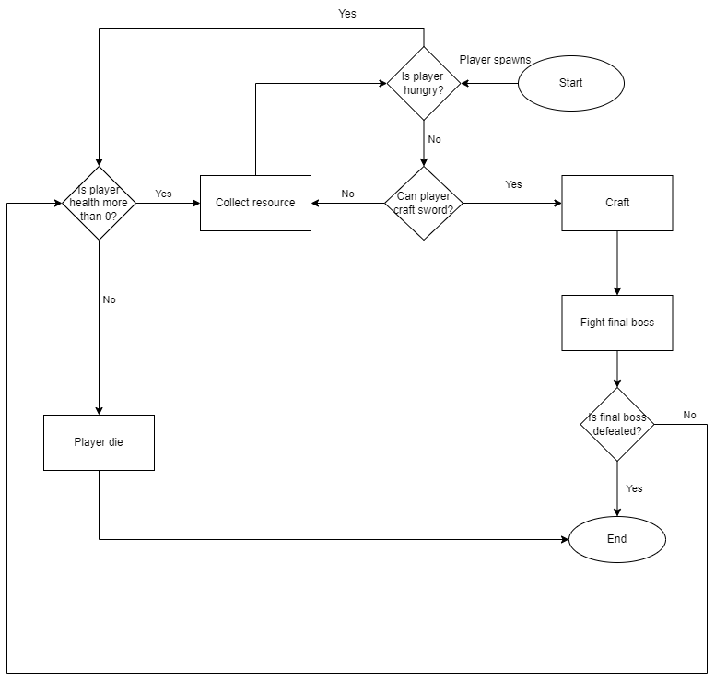

## 2.3 Mechanics

* Player stats

Health points(HP):

Max amount = 100

Use: Upon reaching 0, player dies

Defence (DEF):

Initial amount = 0

Use: Reduces damage taken for the player.

Movement speed:

Initial amount = 1

Stamina:

Max amount = 100

Use: Recharges when player is not dodging

Hunger:

Max amount = 100;

Use: Depletes over time (5 hunger / 10s)

* WASD movement

The player will use WASD to move

* Dodge

The player can dash to dodge enemy attacks. This consumes 33.33 stamina

* Forage

The player can interact with collectible resources to pick them up. Upon pick up, the resource will be transferred to the player’s inventory.

* Food

Food is obtained upon cooking. Consuming food is instant. After consumption, hunger and hp is restored.

* Attack

The player can attack mobs. The damage dealt varies with what the player used to attack with.

* Ranged attack

When the player is equipped with shivs, they can shoot projectiles, damaging mobs

* Dirt pile

The player can interact with dirt piles by using the shovel, producing a sword component. Upon interaction with the shovel, the dirt pile will be consumed and no longer be on the map

* Crafting

The player can use resources gathered to combine them into different and more complex items.

Legend: *Italic means how many output of that item will be produced*

**Bold means how many items are needed to produce that item**

Green coloured boxes are base items

## 

## 

## 

## 

## 

## 

## 

## 

## 

## 

## 

## 

## 2.4 Items

| **Type** | **Item** |
| --- | --- |
| Base | Stick:   * Acquired from the ground by picking up   Stone:   * Acquired from picking up pebbles from ground(same as stick) * Larger yields from mining stone node with pickaxe |
| Tools | Shovel   * Acquired from crafting (2 stones, 1 stick) * Can be used to dig up sword upgrades |
| Build | Campfire   * Placeable on ground. Can’t be placed on top of other objects. * Cooks food * Acquired from crafting (5 sticks) |
| Weapons | Sword:   * Acquired from crafting/mob drops * Default stats:   + ATK: 10   + ATK speed: 1 * Swords are made out of two components, a hilt and a blade, both of which serves its own purpose for the sword.   + Blade: Defines the sword’s base properties and effects   + Hilt: Comes with its own base multiplier, can be enhanced with modifiers. * Upgrades:   + Blade:     1. Katana        - Slightly enhanced base stats from the original sword, inflicts bleeding        - Bleeding: weakens target and depletes their health     2. Cleaver        - Longer range and heavier hitting at the expense of attack speed, inflicts burn        - Burn: depletes target’s health over time by a sizeable amount     3. Dagger        - High attack speed at the cost of damage, inflicts poison        - Poison: decreases target’s movement speed and attack while dealing damage over time   + Hilt:     1. Light:        - Faster attack speed, faster movement speed     2. Ravenous:        - Heals for a % of damage dealt     3. Sharp:        - Higher damage     4. Wide:        - Longer range   Shivs:   * Acquired from mob drop * Right click to fire |
| Food | Raw meat:   * Acquired from killing chickens   Cooked meat:   * Acquired from cooking raw chickens |
| Mob drops | Raw meat:   * Acquired from chickens   Shivs:   * Acquired from skeletons   Ravenous hilt   * Acquired from spider drops * Able to be consumed on crafting menu   Sharp hilt   * Acquired from land octopus drops * Able to be consumed on crafting menu   Light hilt   * Acquired from chicken boss drops * Able to be consumed on crafting menu |

## 2.5 Enemies

| **Type** | **Description** |
| --- | --- |
| Chicken | Passive animal that doesn’t attack the player  Stats  HP: 20 |
| Spider | Aggressive common enemy that keeps a distance from the player while doing ranged attacks.  When player is within a certain distance from the spider, the spider will turn aggressive  Stats:  HP: 30  ATK: 20 |
| Land octopus | Aggressive common enemy that chases the player and does damage at close range  This enemy does not have a field of view.  Stats  HP: 20  ATK: 10 |
| Skeleton | Mini boss that uses ranged attacks  When player is within a certain distance from the skeleton, the skeleton will turn aggressive  Stats  HP:100  ATK:10-30 |
| Bob | Final boss that does damage with both ranged and close combat  Bob does not have a field of view.  Stats  HP:300  ATK:10-30 |

## 2.6 Structures

| **Type** | **Structure** |
| --- | --- |
| Walls | * Serve as a physical obstacle that block players |
| Trees | * Serve as a physical obstacle that block players * More sticks will be spawned near it |

## 2.7 Hunger and health bar

| **Type** | **Structure** |
| --- | --- |
| Hunger | * Decrease gradually over time |
| Health | * Decrease when player gets attacked by enemy, or when hunger bar reaches 0 |

# 3.0 Universe

## 3.1 Story

Stranded on an island, you must protect yourself from those vicious creatures on the island.

## 3.2 Levels

The whole map will be open world and there will only be 2 levels, dungeon and forest. Both are accessed by ladders

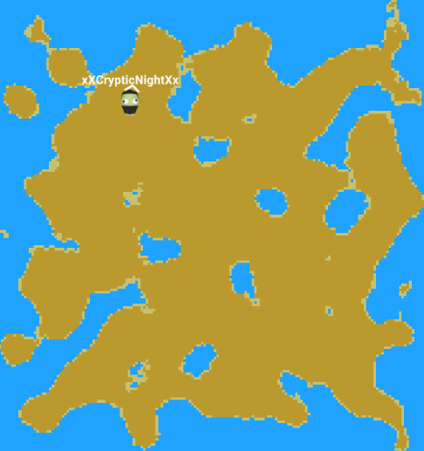

# Control and Interface

## UI and related stuff

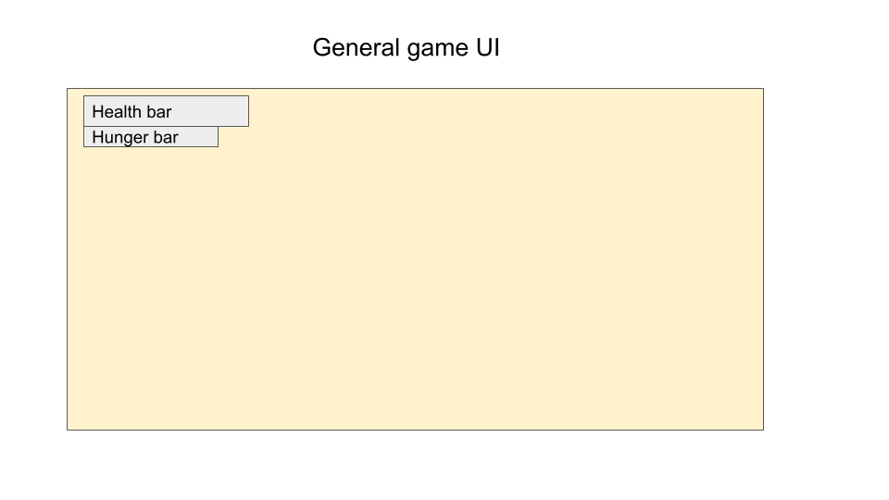

CRAFTING UI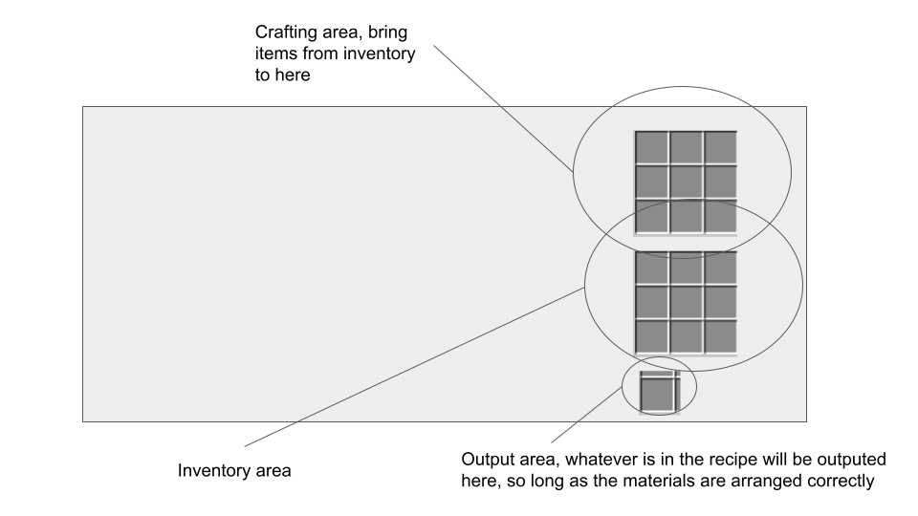

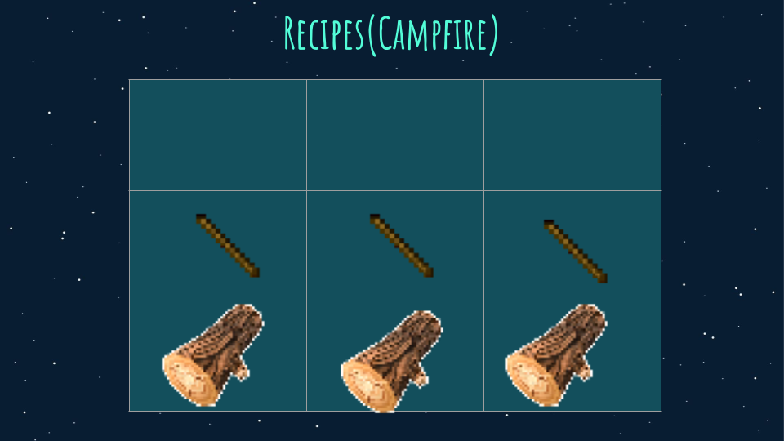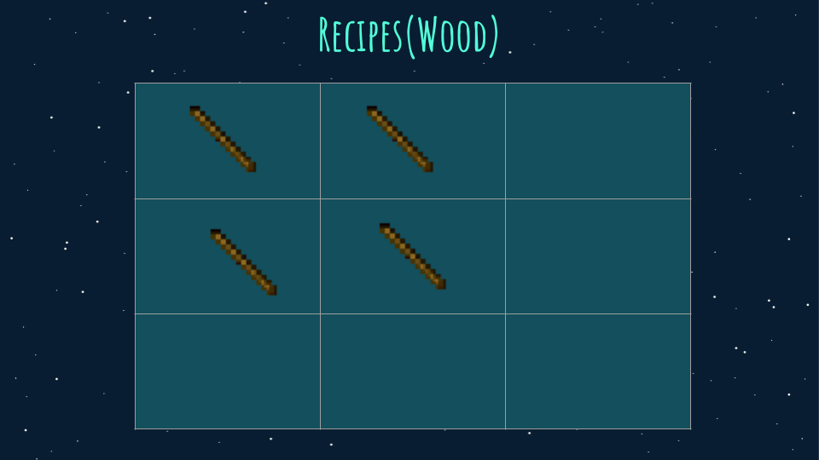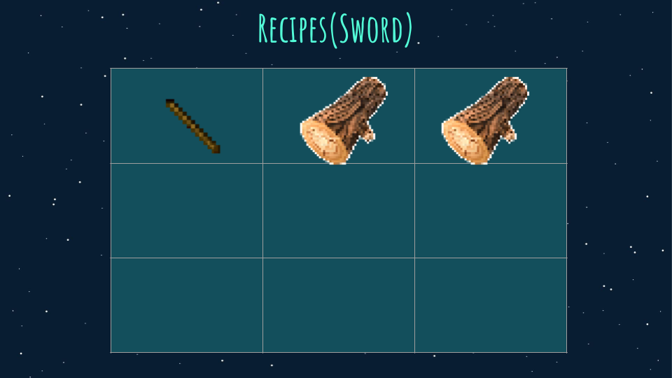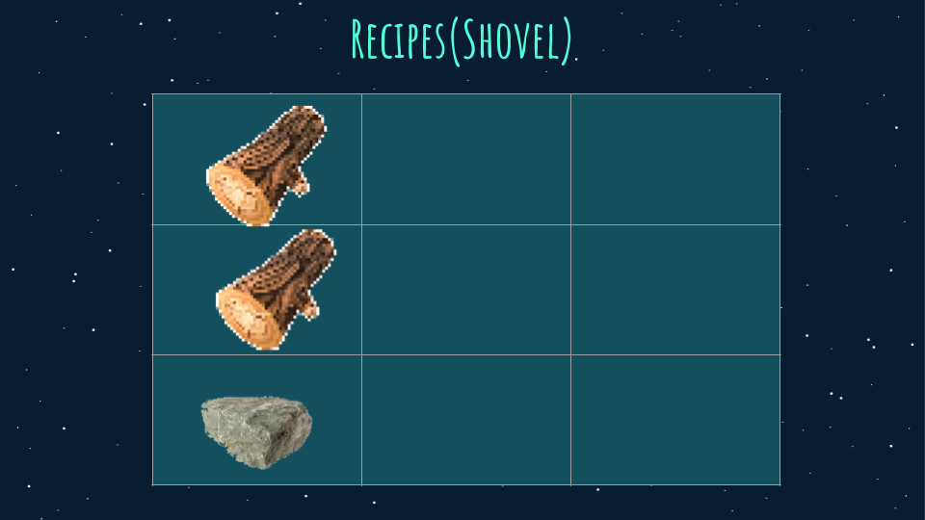

Inventory UI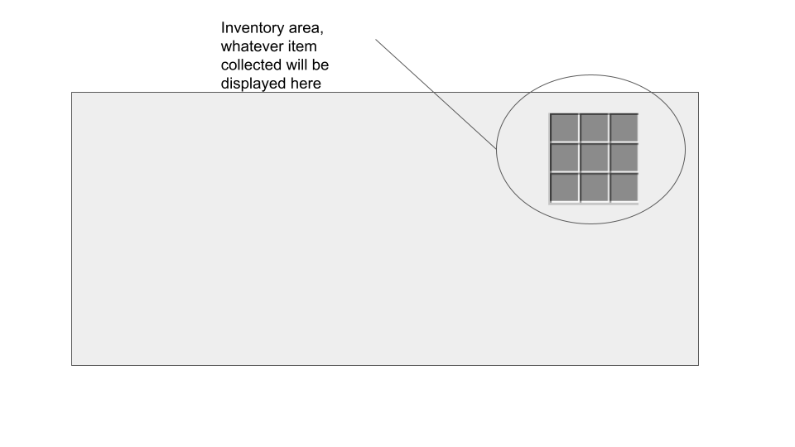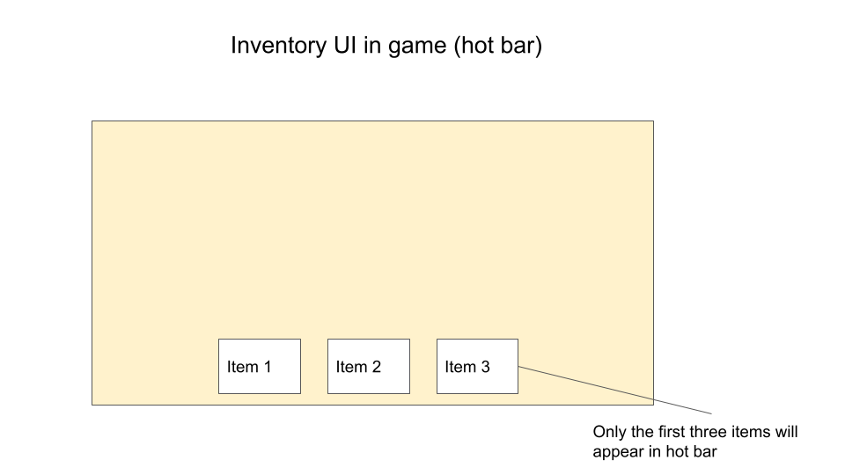

4.2 Controls

W - Move up

A - Move left

S - Move Down

D - Move right

Q - Open/close crafting menu

Spacebar/Left shift - dodge

E - Interact

Left mouse button - Attack

1 - Select 1st item slot on the hotbar

2 - Select 2nd item slot on the hotbar

3 - Select 3rd item slot on the hotbar

# Appendix